Registration by Klokking:
Make an account for your kajakclub and please make sure you remember the password.
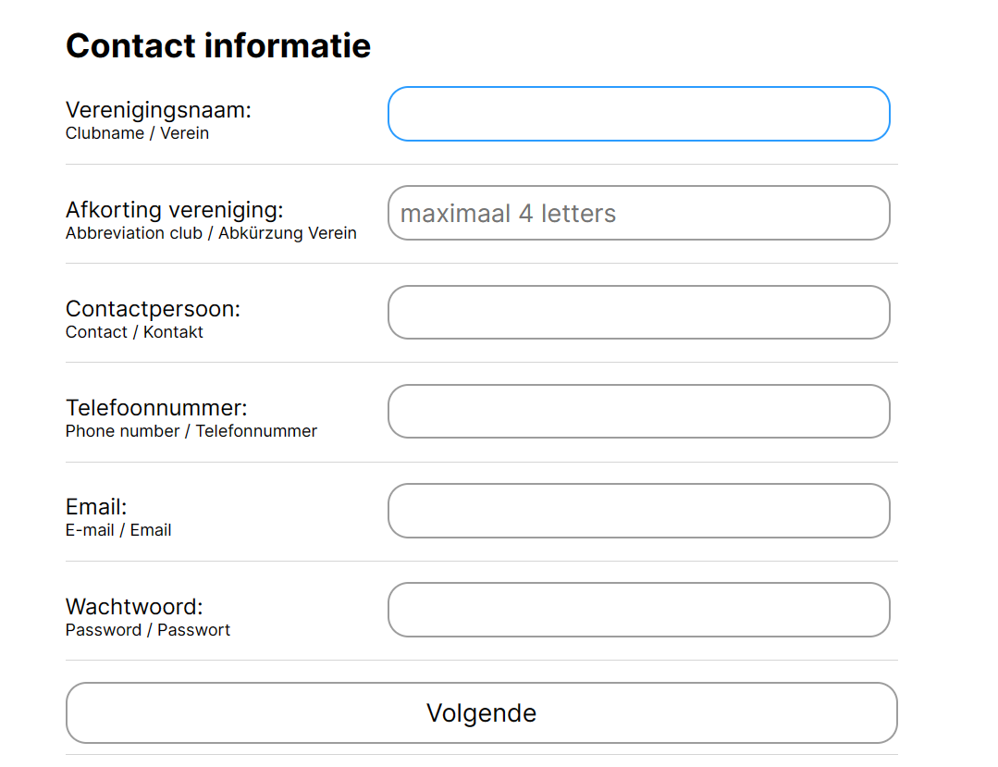
Click on next (blue button) and you can registrate the participants from your club.
Do you already have an account ? Click on choose a club, choose your club and log in with your password.

Registration is per participant:
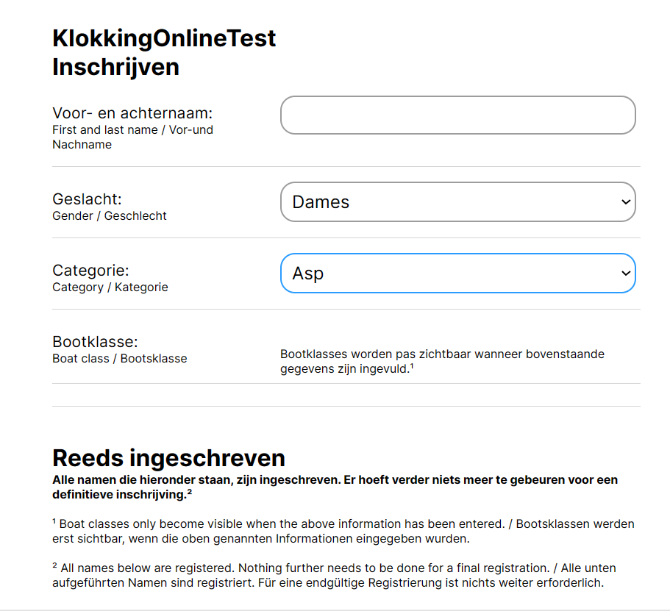
Fill in the data. For K2 and K4 you can alter it afterwards. Under al ingeschreven you can also alter the already registered participants.
Click on register to complete the registration of a participant and a new empty form will appear.
You can view all your registered participants if you scroll down under Reeds ingeschreven.

