Registration by Klokking:

**Make an account for your kajakclub and please make sure you remember the password.**

The registration basically follows the same procedure as last year. You make an account for the club as a whole or use your already existing account**.**

**The only change is the fact that we ask you to register K2 and K4 boats only once.** It is not necessary to register a K2 two times or a K4 four times. If you compete with other club(s), please discuss who will register the boat (so again: just one registration) and use the correct abbreviation.

This year we also have mixed classes for K2 mix.

1. pupils and aspirants
2. junior
3. senior and veterans

And of course these are ladies/gentleman combinations.

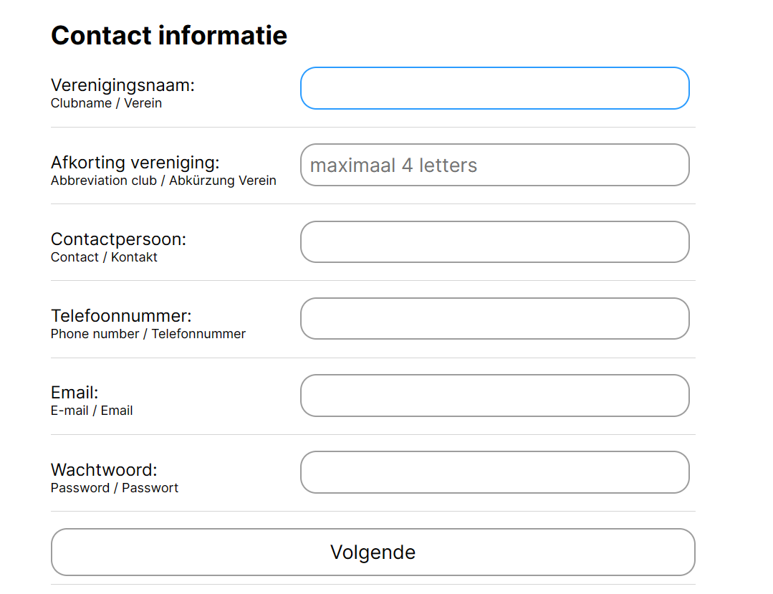

Click on next (blue button) and you can registrate the participants from your club.

Do you already have an account ? Click on choose a club, choose your club and log in with your password.

**Registration is per participant:**

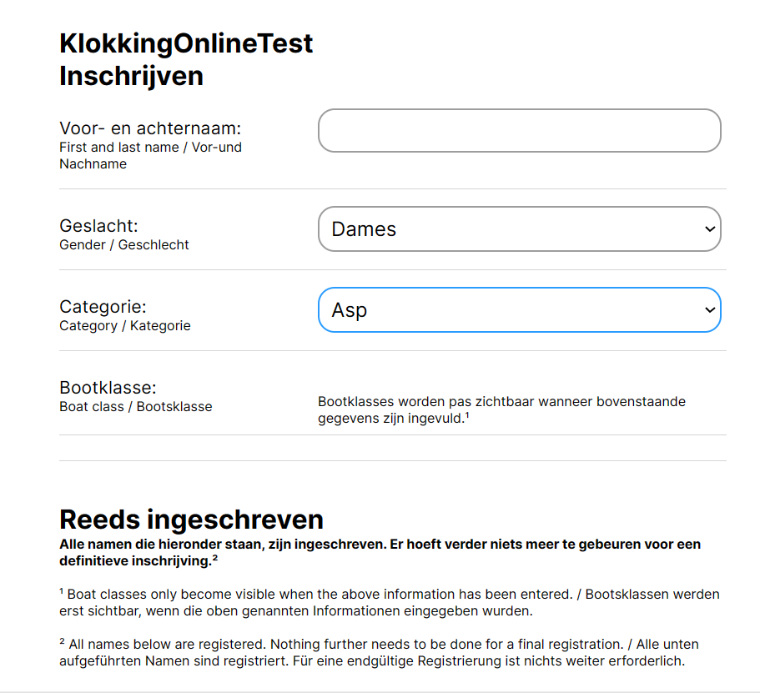

Fill in the data. For K2 and K4 you can alter it afterwards. Under al ingeschreven you can also alter the already registered participants.

Click on register to complete the registration of a participant and a new empty form will appear.

You can view all your registered participants if you scroll down under Reeds ingeschreven.